Senegal

## Political Stability Estimate Data

The data set shows the political stability estimate of the country each year.

## # A tibble: 19 x 5  
## country iso3c date stability stabilityCategory4   
## <chr> <chr> <dbl> <dbl> <chr>   
## 1 Senegal SEN 1996 -0.602 moderately unstable  
## 2 Senegal SEN 1998 -0.986 moderately unstable  
## 3 Senegal SEN 2000 -0.591 moderately unstable  
## 4 Senegal SEN 2002 -0.274 moderately unstable  
## 5 Senegal SEN 2003 -0.250 moderately unstable  
## 6 Senegal SEN 2004 0.0287 moderately stable   
## 7 Senegal SEN 2005 -0.204 moderately unstable  
## 8 Senegal SEN 2006 -0.264 moderately unstable  
## 9 Senegal SEN 2007 -0.244 moderately unstable  
## 10 Senegal SEN 2008 -0.148 moderately unstable  
## 11 Senegal SEN 2009 -0.204 moderately unstable  
## 12 Senegal SEN 2010 -0.418 moderately unstable  
## 13 Senegal SEN 2011 -0.281 moderately unstable  
## 14 Senegal SEN 2012 -0.108 moderately unstable  
## 15 Senegal SEN 2013 -0.0607 moderately unstable  
## 16 Senegal SEN 2014 -0.198 moderately unstable  
## 17 Senegal SEN 2015 -0.117 moderately unstable  
## 18 Senegal SEN 2016 -0.218 moderately unstable  
## 19 Senegal SEN 2017 -0.0447 moderately unstable

## Political Stability Estimate Plot

The plot shows the trends of stabilization and destabilization for the each country.

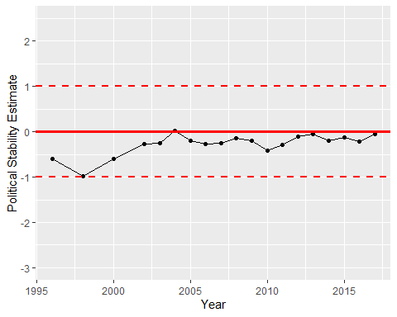

Political Stability Trend